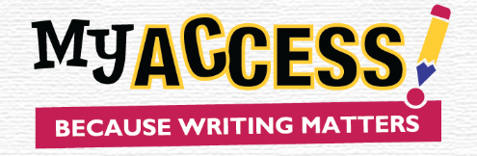 Questions after viewing the MY Access! videos
Video 1 - What is MY Access?
- What is MY Access!
- Which tool in MY Access! will help you with revision?
- Which tool helps you with editing?
- How will the scores help you improve your writing?

Video 2 – How Can I Get to the Assignment?
- Where do I find my assignments?
- What is on the writing page?
- How do I submit my writing for a scores
- How do I get back to the assignment so that I can begin my revision?

Video 3 – How Can I see the Student Special Instructions?
- What kind of information can be shared in Special instructions?
- Where are the two places I can view Special Instructions?
Video 4 – Where are the Tools?
- Where can I find MY Tutor and how will it help me?
- In addition to goals, what other information does MY Tutor provide?
- How do I use MY Editor to correct my errors?
- Where is the Word Bank located and how can it help me improve my writing?
Video 5 – How Can I See the Essays I Submitted?
- Where can I see all my writing and my scores?
- How can I view, print or save any essay?
- Why should I check my portfolio often?

