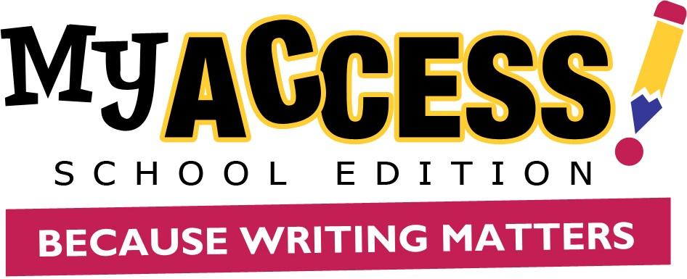

Student User Guide

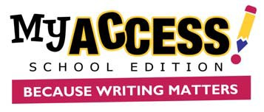
STUDENT GUIDE

Contents
Student User Guide 1
Logging on 3
Modify Account 3
Home Screen 4
Assignments 5
Completing a Writing Assignment 5
Student Writing Screen: Using Tools & Feedback 6
Understanding Your Individual Report 6
MY Tutor® Goals & Revision Plan 7
Understanding Your Portfolio 7
Using Your Portfolio 9
MY Editor and MY Tutor Report 9
Comments 10
Revision Plan 10
Writer’s Models 11
MY Prewriting 11

STUDENT GUIDE

Logging on
Enter the url https://www.myaccess.com. Sign in with the username and password provided by
your teacher.

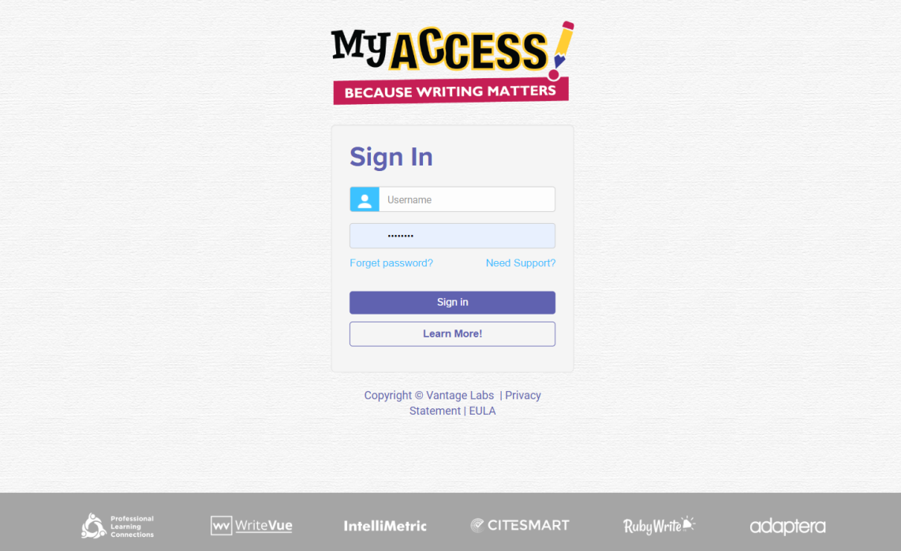

Modify Account

- To modify the information in your profile, click the Gear button in the upper right-hand corner of the Home Screen and then click on User Profile.
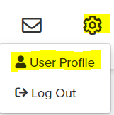
2. You can make changes to your account information in the new window.
3. Click Save and Exit to update the information.

Note. You cannot edit your username. It is also best practice to update your password frequently. Please see your teacher if you forget your username or password.
STUDENT GUIDE

Home Screen
From the Home Screen you can access the Assignments, MY Portfolio, Message Center, Modify Account, and Snapshot Report.

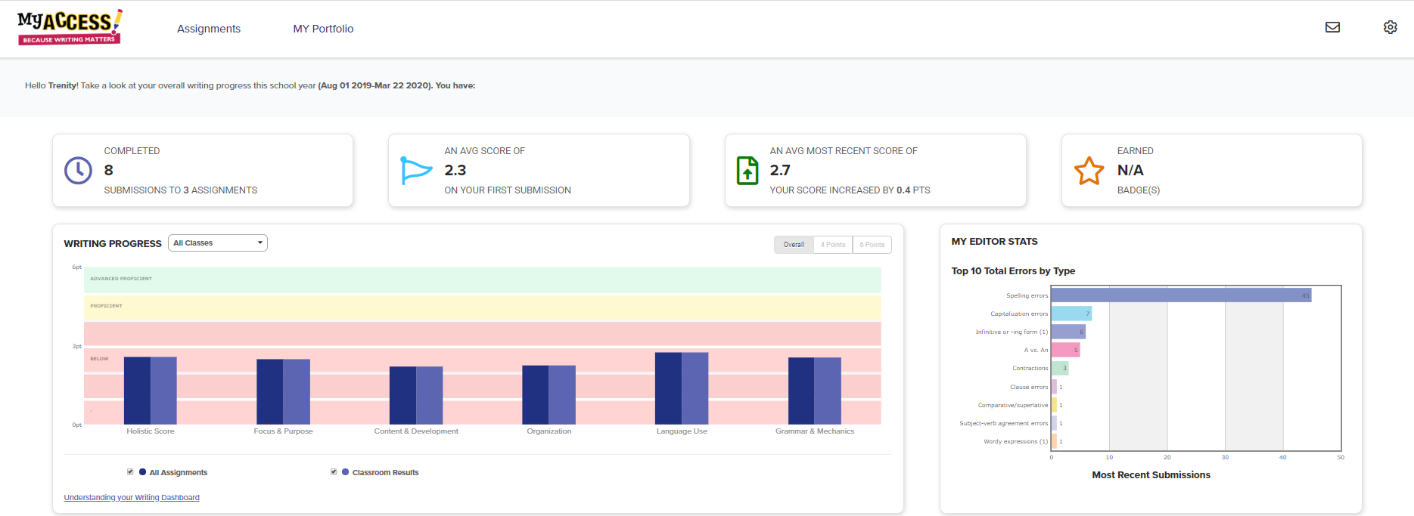

Snapshot Report
The Snapshot Report is where you can view your progress over time. The Snapshot Report is updated nightly
to reflect your holistic or overall writing performance as well as the five trait areas: focus & purpose, content & development, organization, language use, and grammar & mechanics. Your writing progress can fall into one of three levels: at-risk, proficient, or advanced. The Snapshot Report also allows you to quickly filter and view your writing performance for a specific class.

Message Center
The Message Center is located on the Home Screen. The Message Center will automatically alert you when there are new comments entered by your teacher. Once the comment is viewed, the message notification status will automatically be updated.

MY Editor Stats
MY Editor Stats displays your top 10 total errors made on your most recent submissions. For example,
if you have composed and submitted two essays to three writing assignments, MY Access! will automatically sum the errors for each of your most recent submissions and display the top 10 in the MY Editor Status.

Assignments
Under the Assignments tab, you can view the prompt, start a new writing assignment, resume or revise an assignment in progress. Assignments are organized by teacher, school, or district level.

Clicking on the prompt title will display the assignment description and additional prewriting instructions.

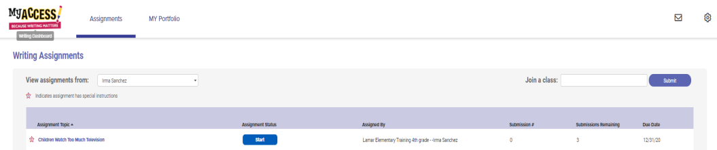

Clicking on the star icon will display special instructions from your teacher. Click Start or click Resume to continue working on a writing assignment.

Completing a Writing Assignment

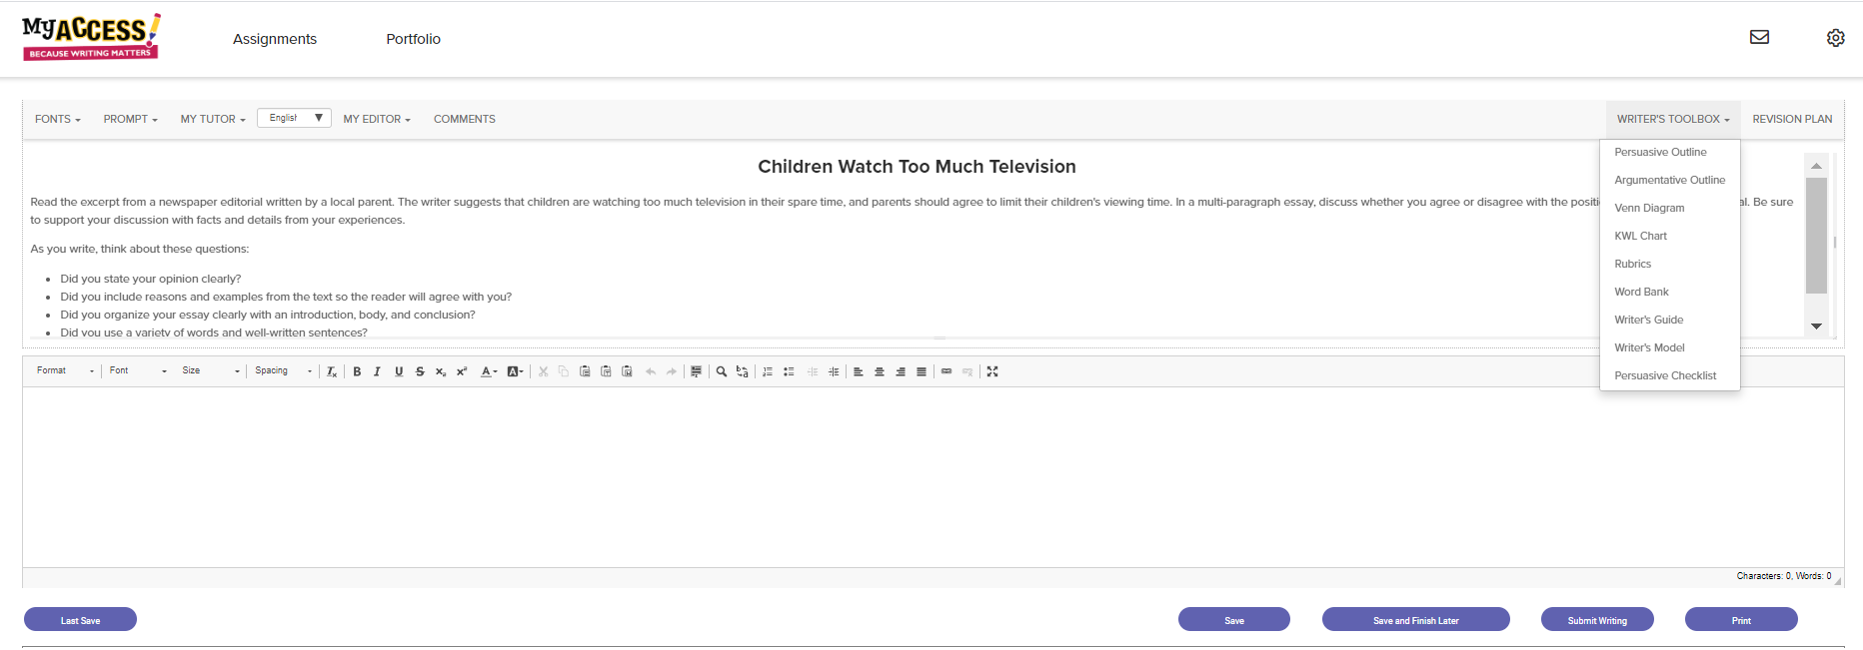
The student work page is divided into two sections. The top box is your assignment information and feedback.
The bottom box is your writing space. This is where you will write your essay.

Once you have completed an assignment, click Submit Writing.

Student Writing Screen: Using Tools & Feedback
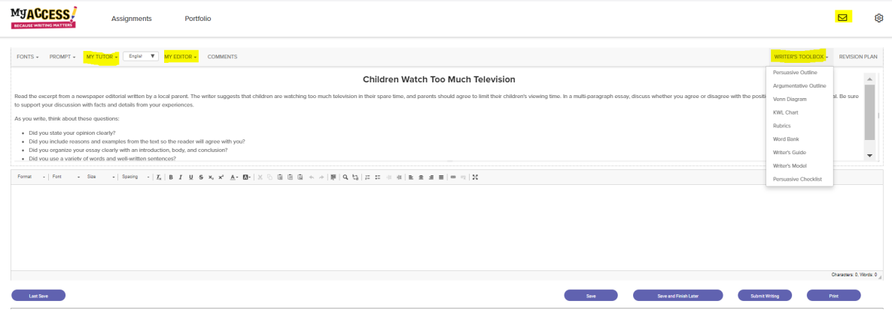
MY Tutor® returns feedback throughout the writing process for each of the five traits: focus & purpose, content & development, organization, language use, and grammar & mechanics.
MY Editor identifies grammar, style, and language errors and returns instructional feedback. MY Editor® feedback is available in English, Spanish, French, Chinese, Japanese, Korean, Simplified Chinese, and British.

- Writer’s Toolbox: Provides you with numerous prewriting tools including access to graphic organizers, rubrics, the Word Bank, Writer’s Guide, writer’s models, and checklists.

- Comments: Displays comments made by your teacher in the feedback window while you are revising your essay.

Understanding Your Individual Report

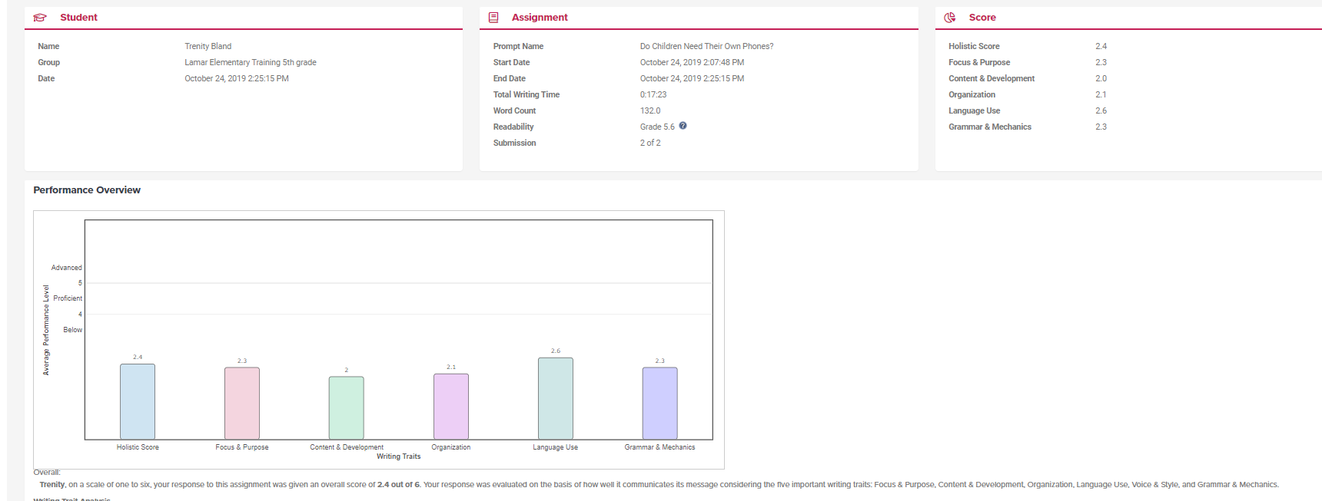
After you click Final Submit, your score and MY Tutor Goals will be displayed immediately. On the bottom of the report, you will see a graph of your writing performance on the assignment you submitted.
Your writing is assessed for its overall quality (holistic score) and for trait specific qualities (focus & purpose, content & development, organization, language use, and grammar & mechanics).

MY Tutor® Goals & Revision Plan

On the bottom of the page is your MY Tutor Revision Plan for this assignment.
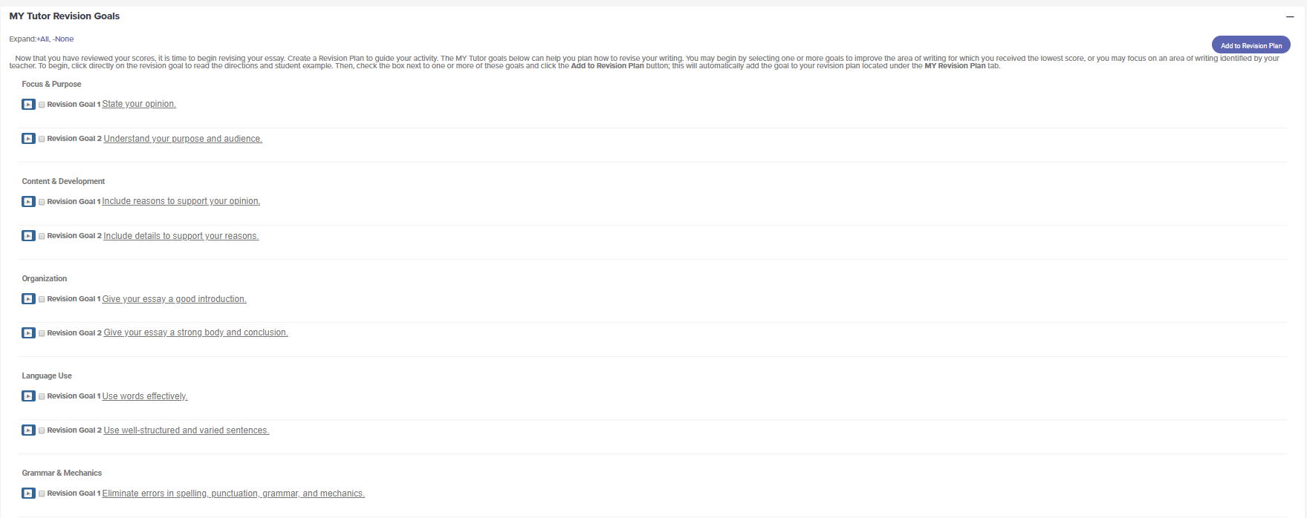

Your Revision Plan is an individualized plan to help you revise and improve your writing.

Begin with the goals under the first writing trait and work your way down the list.

Add a goal to your Revision Plan by checking one or more goals and clicking on the Add to Revision Plan button.

Understanding Your Portfolio
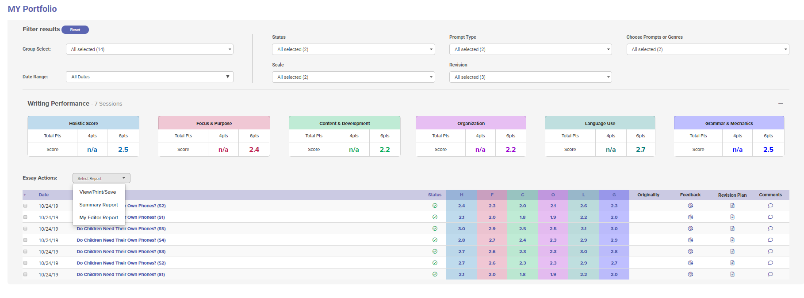
Click MY Portfolio to view all your completed assignments, scores and feedback. Filter Results allows you to limit the number of assignments displayed. Scores display your holistic (overall) score and trait scores.
Comments provide a direct link to post or read teacher comments.
Revision Plan displays your revision plan.

Feedback provides all of your instructional feedback and resources to improve your essay. Originality links to display the CiteSmart Originality Report (if available).

Essay Actions: Provides links to View/Print/Save, Summary Report, and MY Editor Report.

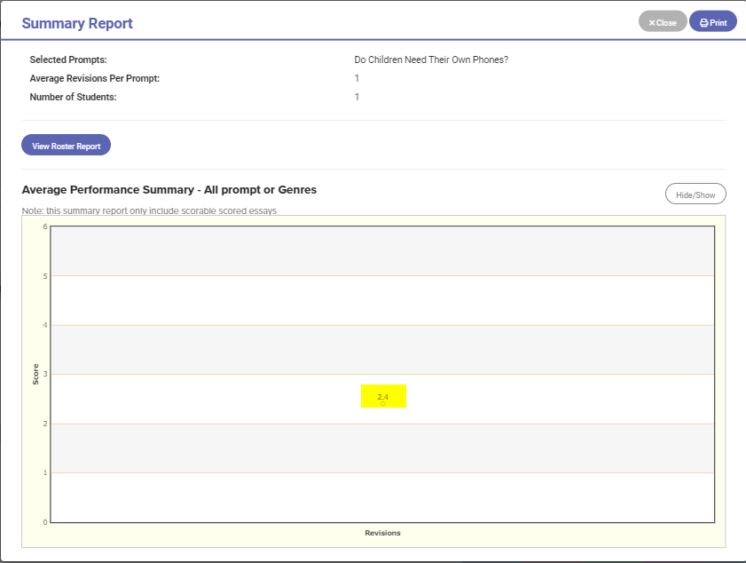
Summary Report: Displays a graph that shows progress over time.

Clicking on a score point will display the holistic and trait scores for that essay.

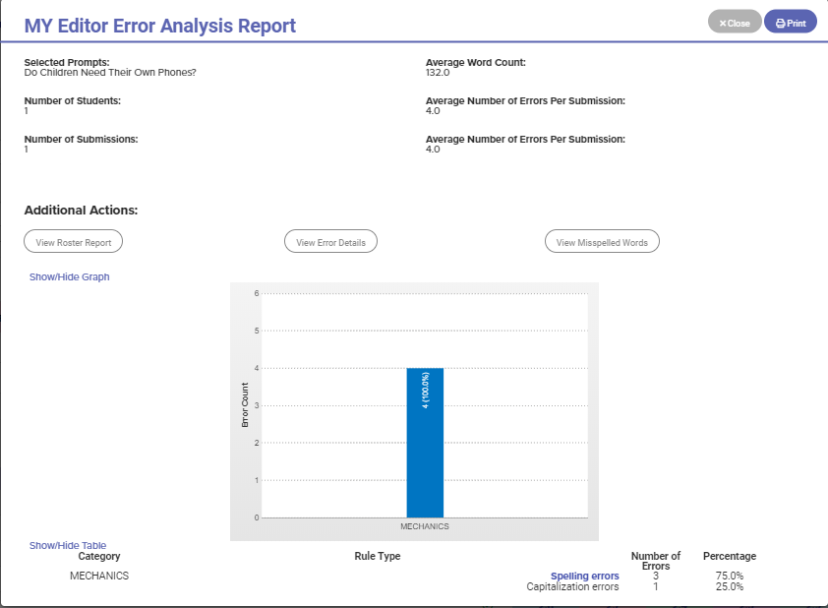

The MY Editor Report summarizes your grammar, mechanics, usage, and style errors.

If you would like to view all your MY Editor reports, you can access them by checking the boxes for the essays that you would like to view.

Using Your Portfolio

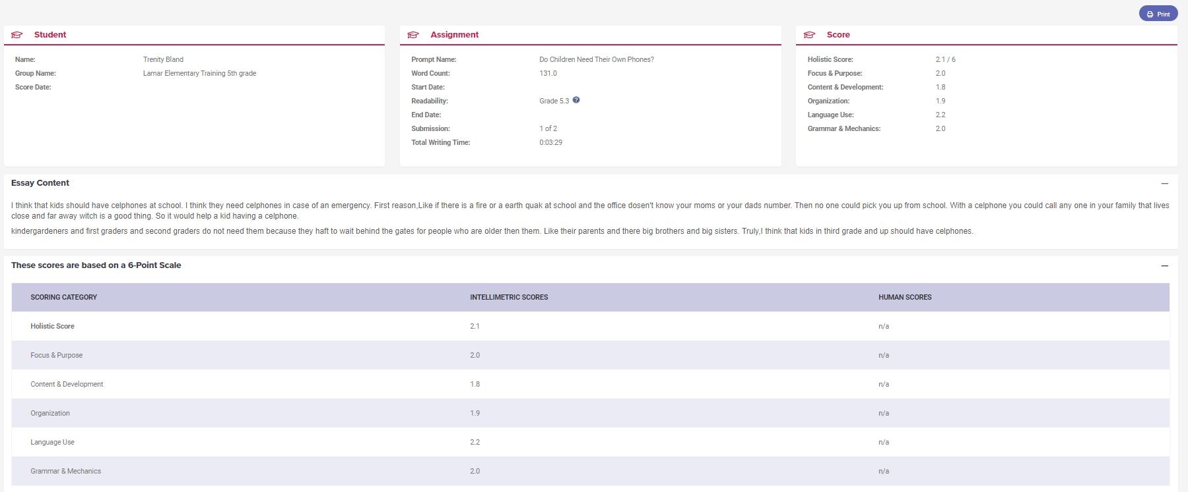
Click on any of your assignment scores to view your essay along with its holistic score and scores in each of the domains: focus & purpose, content & development, organization, language use, and grammar & mechanics.

MY Editor and MY Tutor Report
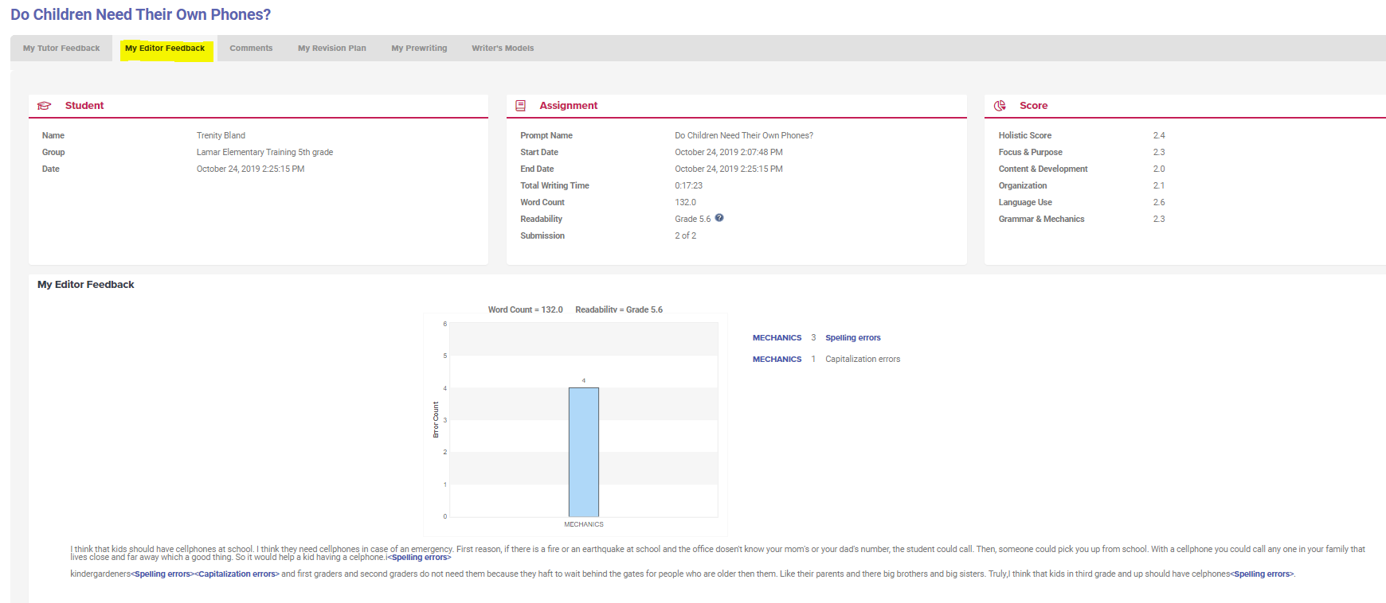

Click the MY Editor Feedback tab to display your error summary and
your group information, assignment start/end date, word count, readability, and holistic and trait scores.

The bottom section of the report contains a graph of the error count by category: Grammar, Mechanics, Style and Usage.

Comments

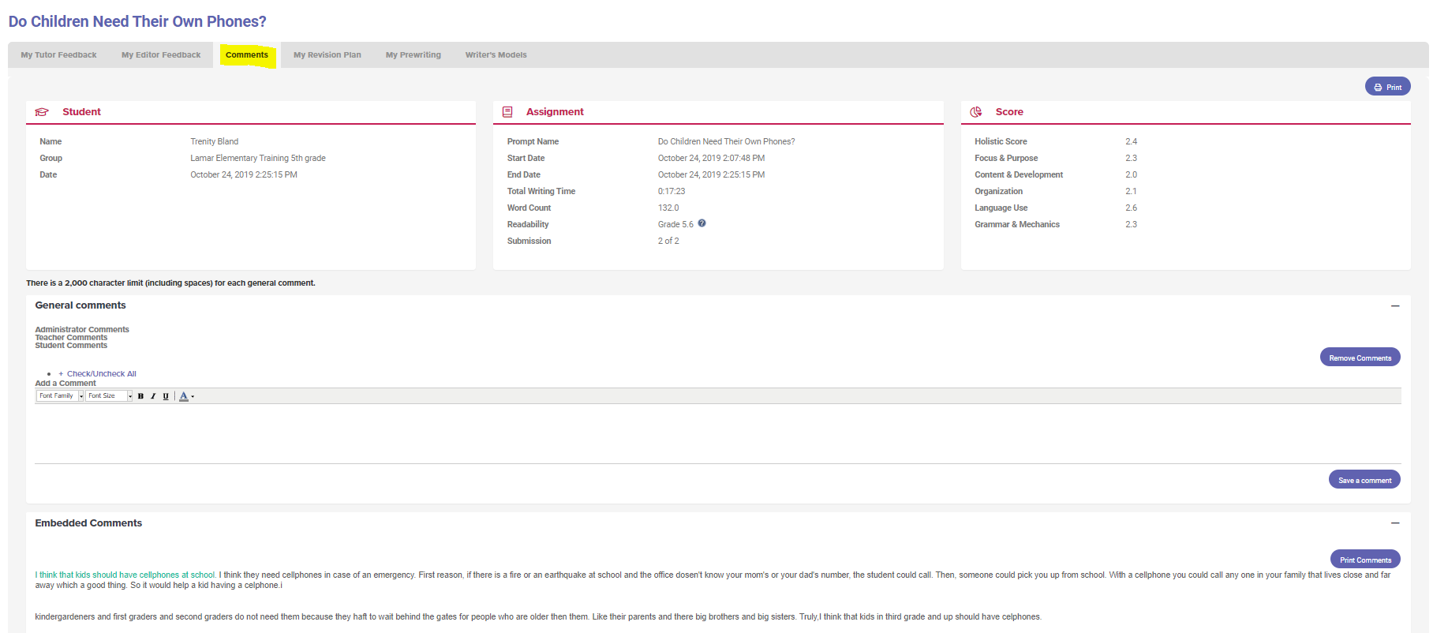

To post or view teacher comments for your essay, click the Comments icon on the portfolio page. To post a comment, click the Add Comment button. To remove a comment, click Remove.
You will be alerted when
new comments are posted.

Revision Plan

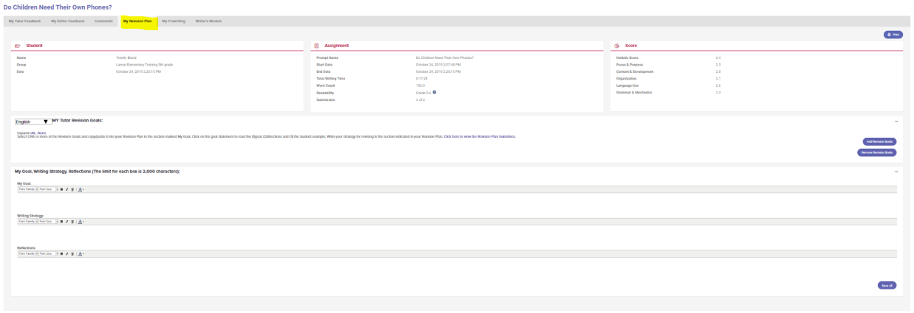
Use your Revision Plan to enter your writing goals, strategies, and reflections in the corresponding text boxes.
You can edit or add to these boxes at any time while you are working in that assignment.

Writer’s Models

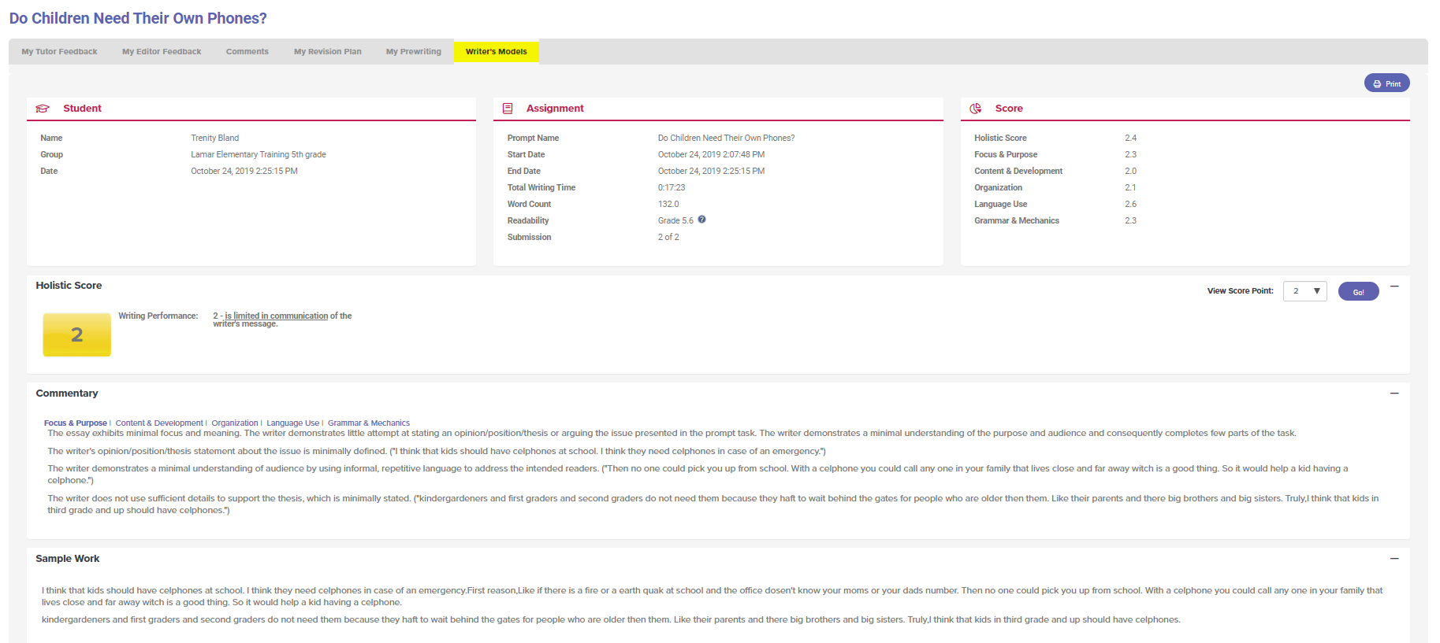

MY Prewriting

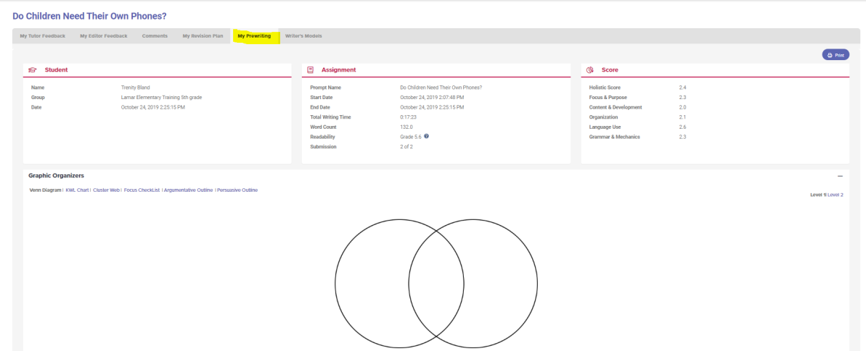

Click on My Prewriting to review the information you included in any of the graphic organizers that you selected.

The Writer’s Models are examples of real student writing that has been scored on either a 4 or 6 point rubric.

Each essay has a commentary that explains why the essay received that specific score.

